Tutorial 3 – Enemy attack.

In order to get the best results, starting with an enemy that already can follow the player and can be killed is easier as we can add in the attack mode. – when the enemy is close enough to the player, we want the enemy to attack.

1. 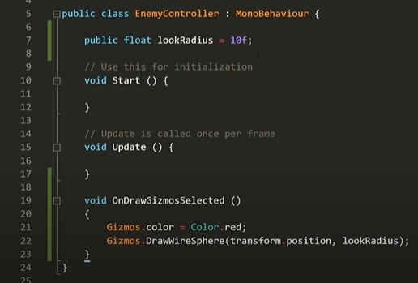The way the enemy follows the player is key when making an enemy attack the player. If we use a radius to detect the player, it will be much easier. Create an enemy controller script and call it EnemyController:

This will draw a radius around your enemy to visually show the area the player will be detected in.

MAKE SURE WHEN CODING AI TO PUT ‘using UnityEngine.AI’

In this script we will make the enemy spot the player and attack them once in range:

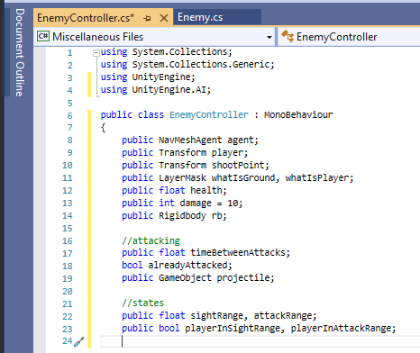

Set these variables

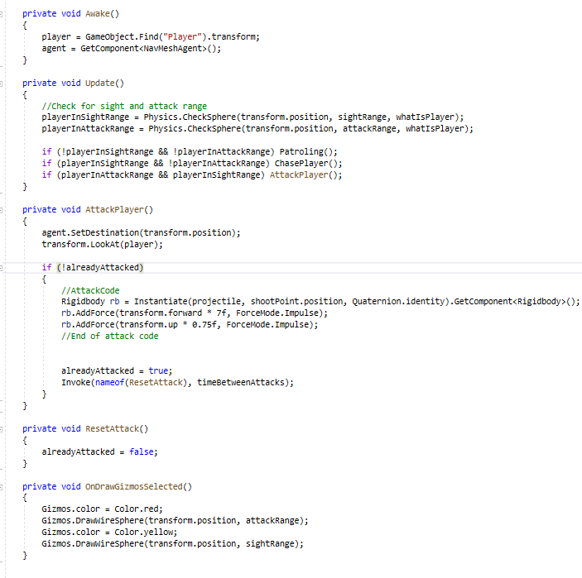

Input this code:

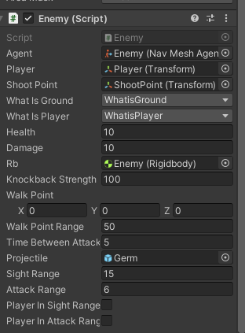Add NavMesh agent, add the script to the enemy and assign all the variables to the correlating objects:

You may have to add two LayerMasks